|  |  |  |  |
| --- | --- | --- | --- |
| **Name of Student: NINAD AVINASH PATIL** | | | |
| **Roll No: 33** | | **Lab Practical Number: 5(A).1** | |
| **Title of Lab Practical: A. Managing States**  **1.Using session variables implement shopping cart. That lets you add up to 5 items from a dropdown list and displays**  **(i)Total number of items selected**  **(ii) List of all Items in the cart**  **There should also be a means of emptying all items in the cart.** | | | |
| **DOP: 16/04/2021** | | **DOS: 19/04/2021** | |
| **CO Mapped: CO1** | **PO Mapped: PO3, PO5, PO7,**  **PO12, PSO1, PSO2** | **Faculty Signature:** | **Marks:** |

**Practical No 5(A).1**

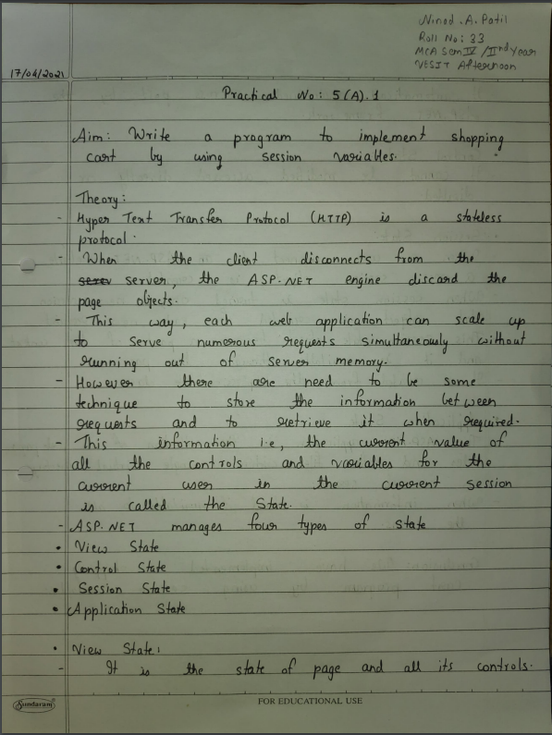

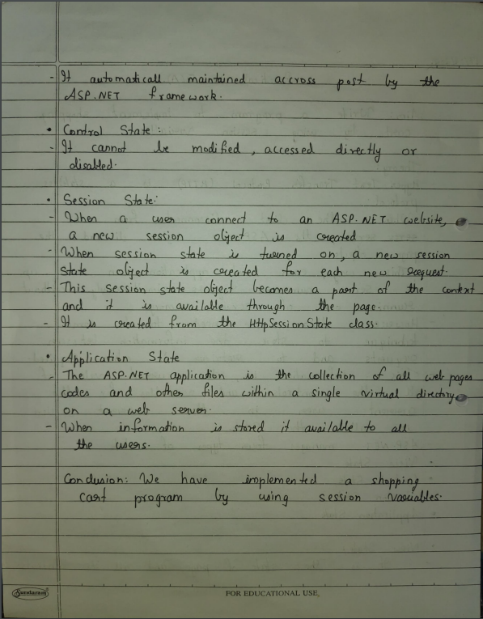

**Code:**

**Cart.aspx.cs**

using System;

using System.Collections.Generic;

using System.Linq;

using System.Web;

using System.Web.UI;

using System.Web.UI.WebControls;

using System.Collections;

namespace P5A {

public partial class WebForm1 : System.Web.UI.Page {

protected void Page_Load(object sender, EventArgs e)

{ }

protected void ddlProduct_SelectedIndexChanged(object sender, EventArgs e)

{ }

protected void btnAdd_Click(object sender, EventArgs e) {

if (ddlProduct.SelectedIndex > 0) {

ArrayList arr = new ArrayList();

if (Session["cart"] != null) {

arr = (ArrayList)Session["cart"];

if (arr.Count > 4)

Response.Write("<script>alert('You can add only 5 items in cart')</script>");

else {

arr.Add(ddlProduct.SelectedItem.Text);

Session["cart"] = arr;

} }

else {

arr.Add(ddlProduct.SelectedItem.Text);

Session["cart"] = arr;

} } }

protected void btnView_Click(object sender, EventArgs e) {

Response.Redirect("ViewCart.aspx");

} } }

**Cart.aspx**

<%@ Page Language="C#" AutoEventWireup="true" CodeBehind="Cart.aspx.cs" Inherits="P5A.WebForm1" %>

<!DOCTYPE html PUBLIC "-//W3C//DTD XHTML 1.0 Transitional//EN" "http://www.w3.org/TR/xhtml1/DTD/xhtml1-transitional.dtd">

<html xmlns="http://www.w3.org/1999/xhtml">

<head runat="server">

<title>Cart</title>

</head>

<body>

<form id="form1" runat="server">

<asp:Label ID="lblSelect" runat="server" Text="Select Product : "></asp:Label>

<asp:DropDownList ID="ddlProduct" runat="server" onselectedindexchanged="ddlProduct_SelectedIndexChanged">

<asp:ListItem Selected="True">Select Product</asp:ListItem>

<asp:ListItem Value="13500">Monitor</asp:ListItem>

<asp:ListItem Value="500">Keyboard</asp:ListItem>

<asp:ListItem Value="350">Mouse</asp:ListItem>

<asp:ListItem Value="4300">External Hard Disk</asp:ListItem>

<asp:ListItem Value="18000">Smartphone</asp:ListItem>

<asp:ListItem Value="25000">Smart TV</asp:ListItem>

</asp:DropDownList>

<asp:Button ID="btnAdd" runat="server" onclick="btnAdd_Click" Text="Add to Cart" />

<asp:Button ID="btnView" runat="server" Onclick="btnView_Click" Text="View Cart" />

</form>

</body>

</html>

**ViewCart.aspx**

<%@ Page Language="C#" AutoEventWireup="true" CodeBehind="ViewCart.aspx.cs" Inherits="P5A.ViewCart" %>

<!DOCTYPE html PUBLIC "-//W3C//DTD XHTML 1.0 Transitional//EN" "http://www.w3.org/TR/xhtml1/DTD/xhtml1-transitional.dtd">

<html xmlns="http://www.w3.org/1999/xhtml">

<head runat="server">

<title>View Cart</title>

</head>

<body>

<form id="form1" runat="server">

<asp:HyperLink ID="hlBack" runat="server" ForeColor="Blue" NavigateUrl="~/Cart.aspx">Go Back</asp:HyperLink>

<br />

<asp:Label ID="lblYourCartProducts" runat="server" Text="Your Cart Products : "></asp:Label>

<br />

<asp:ListBox ID="lbCart" runat="server" Rows="5"></asp:ListBox>

<asp:Button ID="btnRemove" runat="server" onclick="btnRemove_Click" Text="Remove Selected Product" />

<asp:Button ID="btnEmptyCart" runat="server" onclick="btnEmptyCart_Click" Text="Empty Cart" />

<br />

<asp:Label ID="lblCount" runat="server"></asp:Label>

</form>

</body>

</html>

**ViewCart.aspx.cs**

using System;

using System.Collections.Generic;

using System.Linq;

using System.Web;

using System.Web.UI;

using System.Web.UI.WebControls;

using System.Collections;

namespace P5A

{

public partial class ViewCart : System.Web.UI.Page {

protected void Page_Load(object sender, EventArgs e) {

if (Session["cart"] == null)

lblCount.Text = "Cart is Empty...";

else {

ArrayList arr = (ArrayList)Session["cart"];

if (arr.Count > 0) {

lblCount.Text = "Cart has " + arr.Count + " products";

for (int i = 0; i < arr.Count; i++)

lbCart.Items.Add(arr[i].ToString()); }

else

lblCount.Text = "Cart is Empty...";

} }

protected void btnEmptyCart_Click(object sender, EventArgs e) {

ArrayList arr = new ArrayList();

Session["cart"] = arr;

Response.Redirect("ViewCart.aspx"); }

protected void btnRemove_Click(object sender, EventArgs e) {

ArrayList arr = new ArrayList();

if (Session["cart"] != null) {

arr = (ArrayList)Session["cart"];

arr.Remove(lbCart.SelectedItem.Text);

lbCart.Items.Remove(lbCart.SelectedItem.Text);

Session["cart"] = arr;

Response.Redirect("ViewCart.aspx"); }

else

lblCount.Text = "Cart is Empty...";

} } }

**Output:**

